Comparing Photosynthesis and Cellular Respiration

Go to the cellular respiration notes.
Copy the chart on slide 19 into your journal.
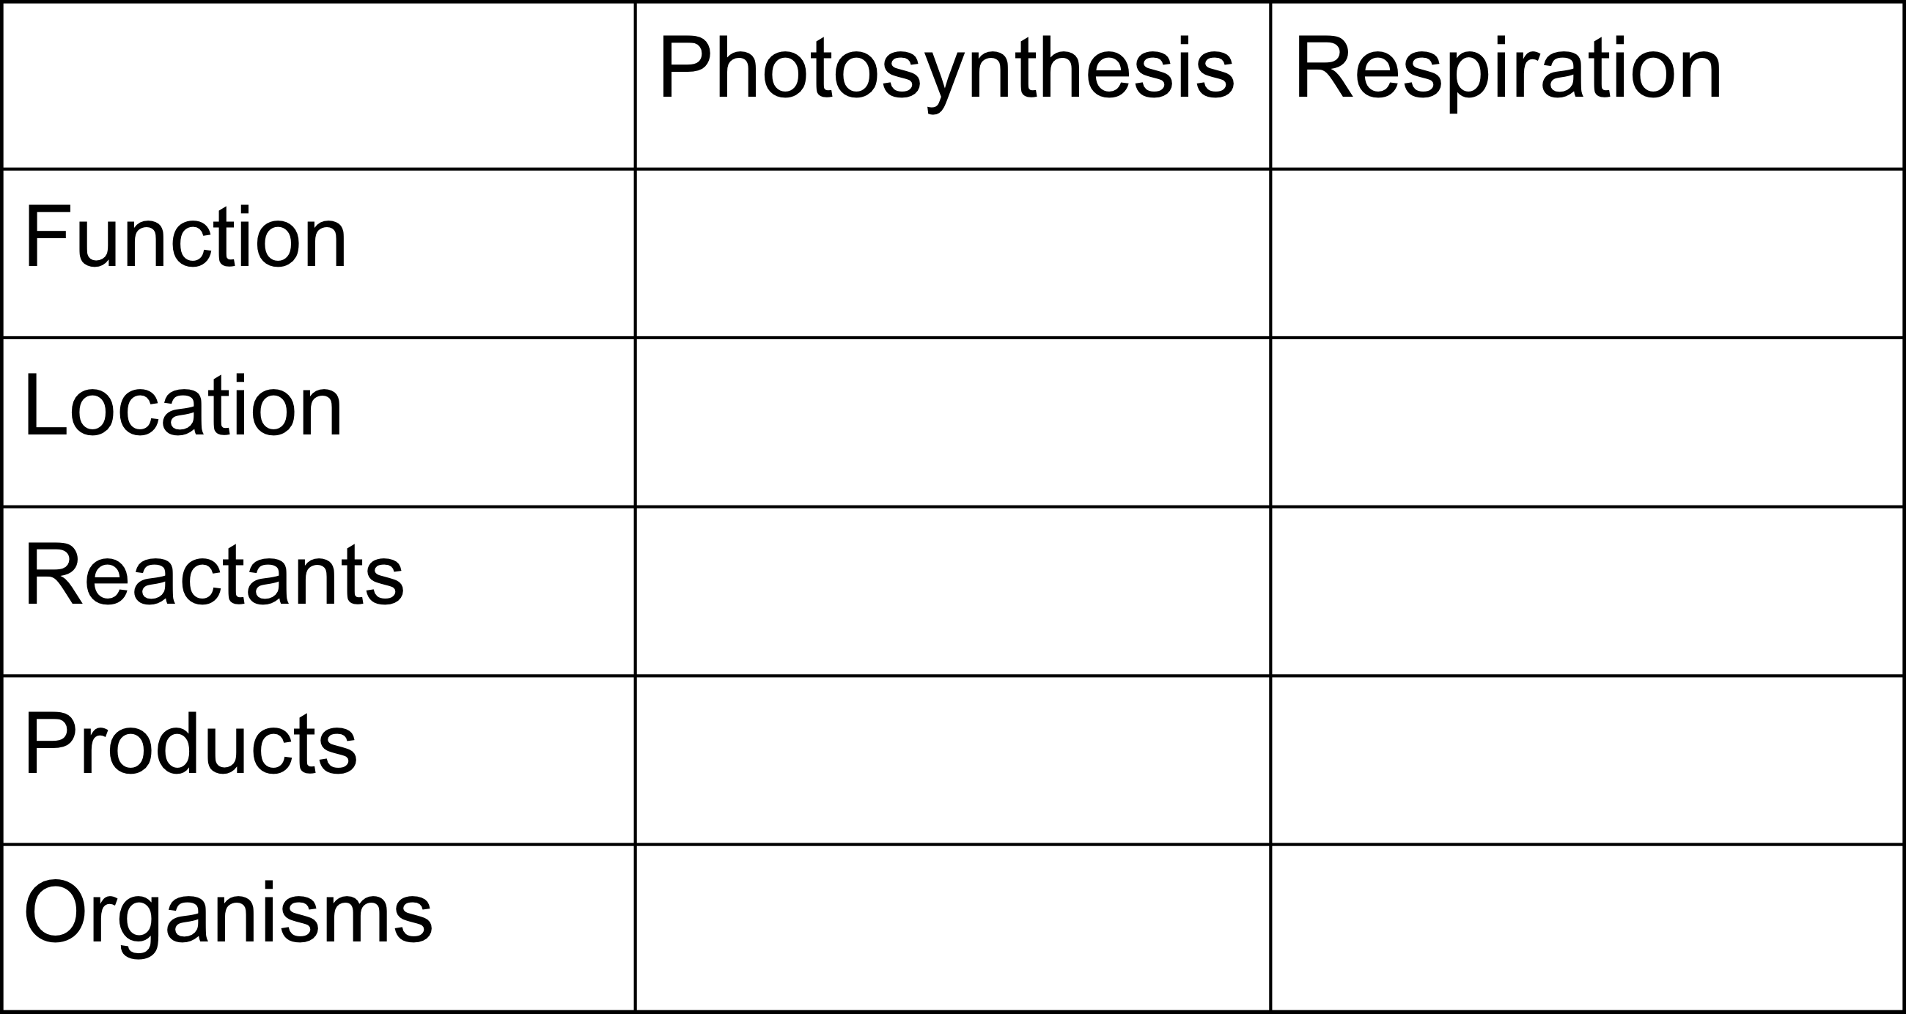
Fill in the information from slides 20-24.
Draw, label and color the diagram on slide 26 onto a sheet of printer paper.
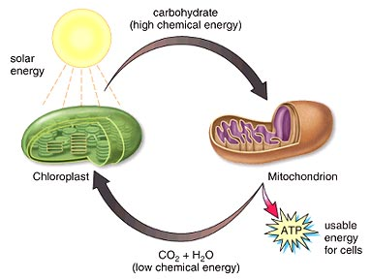
Write the two equations from slide 27 on the printer paper. They can be on the same side as the diagram or on the back.
Go back to the chart you copied from slide 19. On the printer paper, write a paragraph comparing photosynthesis and cellular respiration. Include all information from the chart.

