Name___________________________

Rat Dissection Prelab

For each organ listed, write the main body system that it belongs to and its functions. Choose different colors/designs in color for each organ and color code the two rat diagrams on the back.

This prelab MUST be completed neatly and correctly BEFORE you are allowed to participate in the rat dissection in class.

Organ | Organ System | Functions | Color for Diagrams
Aortic arch
Cecum/Caecum
Colon
Diaphragm
Esophagus
Heart
Liver
Lungs
Pancreas
Small intestine (duodenum, jejunum, ileum)
Spleen
Stomach
Trachea

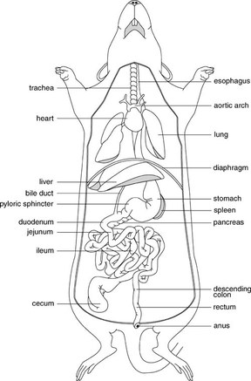 | 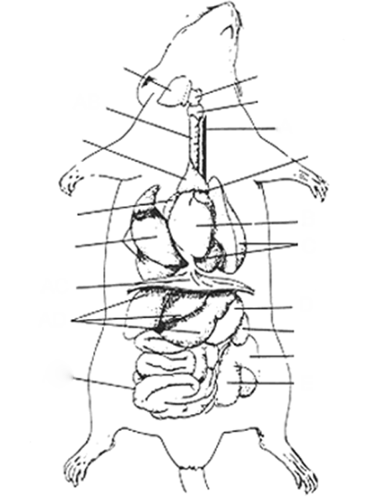

I understand that participation in this lab is a privilege, not a right. The rats are to be used for scientific purposes only, any misuse (playing

around) with the rats is considered disrespectful and will result in automatic exclusion from the lab. Sign Here _________________________________

